DYNAMIC DETERMINATION OF OPTIMUM GROWTH RATE OF LISTERIA MONOCYTOGENES IN MINAS soft CHEESE DURING COLD SHELF-LIFE
Vasco Cadavez^{1*}, Fernanda Bovo Campagnollo², Ursula Gonzales-Barron¹, Anderson Sant’Ana²
¹CIMO Mountain Research Centre, School of Agriculture (ESA), Polytechnic Institute of Bragança, Portugal
²Faculty of Food Engineering, Campinas State University (UNICAMP), Brazil
*E-mail: vcadavez@ipb.pt

Abstract
This study aimed to compare the kinetic parameters of L. monocytogenes during refrigerated shelf-life of soft Minas cheese produced with raw or pasteurised milk, and with or without addition of a cocktail of selected LAB (starter). A dynamic tertiary model based on the Huang and the cardinal parameter models, adjusted to each of the four treatments, determined that the slowest growth (0.0281 ln CFU/g h⁻¹) and the lowest carrying capacity (14.12 ln CFU/g) of L. monocytogenes in Minas cheese was obtained by adding the tailored culture to raw milk.
Huang model, cardinal parameter model, dynamic model, tertiary model

INTRODUCTION

Minas cheeses are Brazilian traditional cheeses, often manufactured by small farmers in an empirical manner using raw milk and indigenous lactic acid bacteria (LAB). From all types of Minas cheeses, the refrigerated soft type has shown the highest frequency of L. monocytogenes recovery (3 – 45%) despite the fact that some strains of indigenous LAB – isolated from the fermented whey collected from previous cheese production – have been shown to inhibit L. monocytogenes. Thus, the objective of this study was to characterise the kinetic parameters of L. monocytogenes during refrigerated shelf-life of soft Minas cheese produced with raw or pasteurised milk, and with or without addition of a cocktail of selected LAB with high acidifying capacity.

methodology
Four different treatments were performed in duplicate, and consisted of production of Minas cheeses using raw or pasteurised milk, and including the addition of starter culture (i.e., six LAB strains with good acidification capacity isolated from commercial Minas cheeses), or without any addition. Ten litres of raw or pasteurised milk were heated to 34±1 ºC and added with 5 mL of CaCl₂, 9 mL of commercial rennet (85% bovine pepsin + 15% bovine chymosin), L. monocytogenes strains 3968 –1/2b and 3973 – 4b (10⁵ - 10⁶ CFU/mL of milk) and/or selected LAB (10⁶ - 10⁷ CFU/mL of milk), depending upon the treatment. After 40 min coagulation, curd cutting, slightly agitation and resting for 30 min, sodium chloride (2 g/L) was added and curd was allowed to rest for another 30 min. The whey was drained off and curd was placed into perforated moulds. Cheeses were maintained at room temperature for 1 h for dripping, turned and left for an additional 1 h for final dripping. Unmoulded cheeses were packed in plastic bags and stored at 7±1 ºC for 15 days. Microbiological analyses of cheese at determined intervals during refrigerated shelf-life included LAB and L. monocytogenes counting (ln CFU/g). Also, cheese pH, water activity (Aw) and temperature were measured.

Taking into consideration that pH and Aw continuously drop during storage, the kinetic parameters of L. monocytogenes in fermenting cheese, for each of the four treatments, were determined by dynamic kinetic analysis; this is, by simultaneously fitting a primary growth model (Huang model, Eq. 1) in differential form with an explicit secondary model of the specific growth rate as a function of the cheese pH and Aw (Cardinal parameter model, Eq. 2),
$\frac{dY}{dt}=\frac{μ_{max}}{1+e^{-4t)}}\left(1-e^{Y-Y_{max}}\right)$ (Eq. 1)
$μ_{max}=μ_{opt}\left\{\frac{\left(pH-{pH}_{min}\right)\left(pH-{pH}_{max}\right)}{\left(pH-{pH}_{min}\right)\left(pH-{pH}_{max}\right)-{\left(pH-{pH}_{opt}\right)}^{2}}\right\}\left\{\frac{a_{w}-a_{w min}}{1-a_{w min}}\right\}$ (Eq. 2)
where Y₀, Y_{max} and Y are the natural log of bacterial counts at time 0, maximum level and time t; μ_{max} is the specific growth rate (ln CFU/g h⁻¹); while pH_{min} and pH_{max} are the pH below or above which no growth occurs, pH_{opt} is the pH at which the specific growth μ_{max} is optimal; a_{w min} is the water activity below which no growth occurs; μ_{opt} is the optimum growth rate at pH_{opt} and aw_{opt} (fixed at 1.0). Because the cardinal parameters of L. monocytogenes (pH_{min}, pH_{opt}, pH_{max} and a_{wmin}) are not estimable from the data – as the monitored pH (7.0 to 4.7) and a_{w} (0.999 to 0.993) of the Minas cheese correspond to narrow-ranged suboptimal values, they were set to values determined from liquid media (pH_{min}=4.71; pH_{opt}=7.10; pH_{max}=9.61; a_{wmin}=0.913).

Results
Since the LAB strains, making up the starter culture, were purposely chosen for their high acidifying capacity, the treatments with starters, added either in raw or pasteurised milk, caused a greater drop in cheese pH than those treatments with autochthonous LAB (Fig. 1). Thus, in competition with the selected LAB strains, L. monocytogenes suffered a retarded growth, as suggested by the change in optimum growth rate μ_{opt} in pasteurised cheese without starter, from 0.0405 ln CFU/g h⁻¹ to 0.0336 ln CFU/g h⁻¹ when selected LAB were added. The same trend was observed in raw milk cheeses, whereby the growth of L. monocytogenes in cheeses with starter (0.0281 ln CFU/g h⁻¹) was slower than in those without starter (0.0389 ln CFU/g h⁻¹). Likewise, the addition of selected LAB brought down the carrying capacity of L. monocytogenes in pasteurised and raw milk cheese (from 17.76 and 17.91 ln CFU/g, respectively, when no starters were used) to 14.83 and 14.12 ln CFU/g, respectively (Table 1). Furthermore, regardless of the addition or not of starter cultures, the growth of L. monocytogenes was slightly faster in cheeses elaborated with pasteurised milk. This was expected since pasteurisation eliminates a large part of background flora in milk, thereby weakening microbial competition and enhancing pathogen growth. Thus, when cheese was made of pasteurised milk without selected LAB – hence relying only on autochthonous LAB – the optimum growth rate of L. monocytogenes was the highest, which can be at least partly explained by the poor acidification taking place in these cheeses (pH from 7.0 to 6.7; Fig. 1). On the other hand, the treatment producing the best acidification profile (i.e., raw milk with starter; pH from 6.7 to 4.8; Fig. 1) supported the slowest development of L. monocytogenes (Table 1). Although the LAB strains tested did not cause an inactivation of L. monocytogenes, they did exert a strong bacteriostatic effect, as inferred from the only one-ln CFU/g growth that took place in 15 days of cold storage (from Y₀=13.11 to Y_{max} 14.12 ln CFU/g; Table 1).
Table 1. Kinetic parameters (initial and maximum microbial concentration Y₀, Y_{max} in ln CFU/g and optimum growth rate μ_{opt} in ln CFU/g h⁻¹) of L. monocytogenes in Minas soft cheese elaborated with raw or pasteurised milk and with addition or not of starter culture (selected LAB)
Milk |  | Without starter |  | With starter
 | Parameters | Mean (SE) | Pr > |t| | Mean (SE) | Pr > |t|
Pasteurised | Y₀ | 14.71 (0.385) | <.0001 | 13.15 (0.142) | <.0001
 | μ_{opt} | 0.0405 (0.0135) | 0.0122 | 0.0336 (0.0070) | 0.0006
 | Y_{max} | 17.76 (0.272) | <.0001 | 14.83 (0.143) | <.0001
Raw | Y₀ | 14.58 (0.241) | <.0001 | 13.11 (0.115) | <.0001
 | μ_{opt} | 0.0389 (0.0068) | 0.0010 | 0.0281 (0.0067) | 0.0029
 | Y_{max} | 17.91 (0.193) | <.0001 | 14.12 (0.072) | <.0001
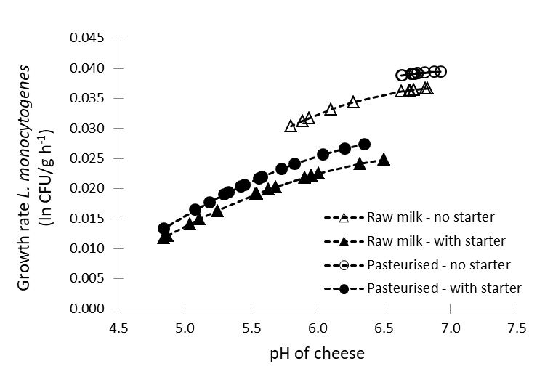
Figure 1. Effect of pH on the growth rate of L. monocytogenes in Minas soft cheese by treatment. Markers indicate sampling points from time 0 (rightmost) to 360 h (leftmost)

